**Photogrammetry Protocol (Ocean Recoveries Lab – University of California Santa Barbara)**

**Purpose:** Create digital meshes from still images of single objects (example: *Pocillopora* coral colonies) to perform simple and complex 3D morphometric measurements

**Software:** Adobe Lightroom, Agisoft Metashape Pro, Meshlab

**Cameras:** Our cameras: Olympus TG-5 (set to wide angle mode), Canon G16 with FantaSea FG-16 housing and BigEye Mark II wide angle adapter

Other underwater photogrammetry options: Panasonic LX100 and Nikon D300 DSLR both with Ikelite camera housings, Nikon AF-S DX NIKKOR 18-105 mm lens, GoPro Hero 3 black edition

**1. Image Preparation**

**Image Capture**

We modified our protocol for photographing focal coral colonies by adapting the methods outlined in Ferrari et al. (2017). Image capture usually took ~10 minutes per focal object

* Place a 3D scale bar (for instance, a Rubik’s cube attached to a dive weight) in a location where it will be included in most photographs while limiting obstruction of the focal object. **Note**: Other 3D scale bars, such as those with “targets” included, may help with automation of scale bar alignment and provide more precise calibration. A single 2D scale bar such as a ruler could also be used, though possibly with diminished accuracy – see note about scale bar calibration
* From a distance of ~100cm, complete one 360o photographic pass while remaining horizontally perpendicular to the focal object, taking photos every 1-2 seconds and ensuring ~80% overlap between subsequent images (minimum 20 images)
* Repeat a second 360o photographic pass, punctuated by 8 semi-arcs (one semi-arc every 45o). For each semi-arc, capture images every 1-2 seconds while slowly transitioning from a horizontally perpendicular to vertically perpendicular angle, then returning to a horizontally perpendicular angle. As best as possible, maintain distances of 50-100 cm from focal objects. Each complete semi-arc generally consists of ~15 images. Collectively, these 8 “back-and-forth” semi-arcs imitate the 8 one-way arcs suggested by Ferrari et al. (2017) while minimizing diver movement and maximizing efficiency.

General tips for high-quality photography:

* As often as possible, capture entire focal object in image and as much of the scale bar as possible. A follow-up set of closer-up images may be necessary for extremely complex focal objects (i.e., large, tightly-branched corals), but sets of images that are all too close with no obvious location references will not align well.
* Use prime lens (focal length stays fixed)
* Do not zoom in/out, and ensure object is in focus
* Do not use flash (maintain even, natural lighting)
* If possible, capture images in RAW or highest quality available format
* Adjust photography settings (ISO, F-stop, shutter speed, etc.) per focal object as necessary as lighting and conditions change to capture a consistent image quality (though differences among image sets can be accounted for in post-processing)

Specific tips for photographing underwater or of corals:

* If diver movement creates turbidity, wait for sand to settle before resuming imaging
* If photographing corals with resident fishes and invertebrates, clear before photography, especially if organisms are large, highly abundant, or obstruct coral morphology
* Adjust white balance before beginning each new set of photographs
* Take a subset of photographs (10-20) from angles that include the underside of branched corals, which are often excluded as “holes” in completed meshes if not captured

**Post-Processing**

***Editing/Image adjustment***

Image adjustment to obtain a consistent appearance or quality both within and among sets of images can be performed using various editing applications. Here, we provide instructions for Adobe Lightroom, though [various free alternatives are available](https://skylum.com/blog/guide-to-the-best-free-lightroom-alternatives). Image adjustment took ~5 minutes per focal object.

For imaging corals, we adjusted batches of photos based by applying adjustments that were calibrated on one representative image per photo set - usually a horizontally perpendicular photograph where the focal coral was entirely in view and both the background and coral were in sharp focus and evenly lit. In our relatively homogenous sets of photographs from clear, shallow, tropical waters, further adjustments of individual photographs within a collection of images of one focal object was not usually necessary.

The general goal of photo adjustments should be to manipulate images until:

* Color is consistent and accurate (natural lighting as if midday at sea level)
* Fine features of focal object are sharp and distinct
* Focal object is distinguished from background
* Focal object is evenly lit, avoiding overexposure of lighter areas and over-darkening/obscuring shadowed areas

First, save photos for each focal object into a new Album in Lightroom – this will make batch processing easier.

Below are several settings that may need to be adjusted to create images that are conducive to accurate alignment, especially for underwater photography with notes relevant to branching coral colonies.

***Color***

* Use the white balance eyedropper tool to select a neutral pixel color. If available, try and select a consistent object across all photographs (e.g., cinderblock, white face of Rubik’s cube, sand) and a location not shaded by natural lighting or the focal object. Click a few locations until the object appears consistent with other image sets and passes a general eyeball test for color accuracy.
* Using the eyedropper will adjust “**Temp**” and “**tint**” automatically, further manual tweaking is usually not necessary. On our average coral image, white balancing increased temp slightly (~+20) and decreased tint decreased slightly (~-10), though those magnitudes and even directions varied among image sets.
* **Vibrance** may be slightly adjusted (usually increased) to enhance contrast. Saturation should not be adjusted.

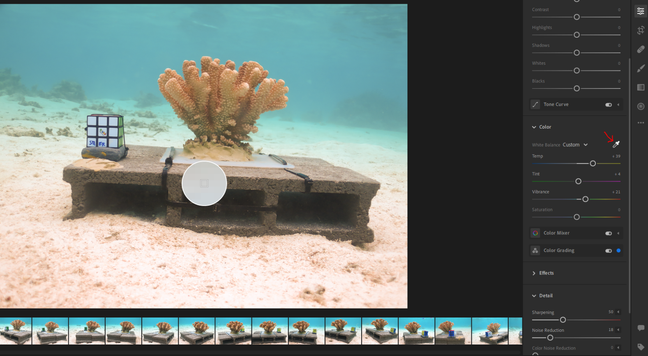

***Light***

* **Exposure**: Often has to be slightly increased (usually <0.5 units). For corals: adjust until branch tips are well-lit (but not overexposed/bleached out) and features within interstices are illuminated
* **Contrast**: Often has to be increased to sharpen features of focal object (usually <50 units). Increase until fine details of focal object (such as coral verrucae) are distinct and clear from background, but increasing contrast too far will skew colors and hide features in shadowed areas (interstices or base of coral)
* **Highlights**: If background or focal object features have too much glare in lighter areas, can be adjusted downward. Adjusting upward may help illuminate darkened areas, but be careful not to wash out features of focal object or background that will be helpful for alignment. Can be adjusted up to 100 units in either direction.
* **Shadows**: If objects feature shadows that obscure detail, can increase to create more even lighting. Often has to be increased all the way to +100 to lighten the interstices of complex corals. Contrast may need adjustment in tandem with highlights and shadows to obtain best balance of sharpness and even, appropriate lighting for the subject.
* **Whites/Blacks**: Similar to highlights and shadows, but effects are more pronounced. Subtle adjustments may be necessary but it is very easy to wash out or over-darken subject

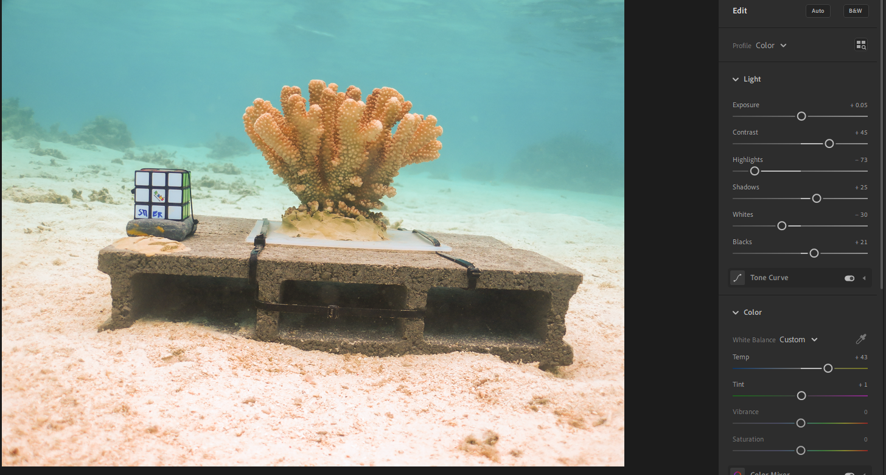

***Effects***

* **Texture**: Increasing can help increase image sharpness and contrast. Decreasing will blur out features that are important for photo alignment and analysis. Increasing too far will create noise, so if desired usually limit to <50 (though higher may be possible with subsequent re-adjustment of color or noise reduction).
* **Clarity**: Will sharpen edges of object and make more distinct from background, but if raised too high will create too much contrast and overshadow fine features of focal object (such as coral interstices). Slight increases may be helpful, but should never be decreased
* **Dehaze**: Can help remove any effects of overexposure or photo elements being washed out, but will also quickly over-darken any shadowed features of focal object. Adjustments to highlights, shadows, whites, and blacks are preferable. If any adjustments to dehaze are necessary, slight increases are best
* Do not adjust **vignette** or **grain**

***Detail***

* **Sharpening**: Will enhance detail in image, but increase noise. Moderate upward adjustment is often helpful to increase detail of focal objects, such as coral verrucae (usually <50 units)
* **Noise Reduction**: Usually increase half to 2/3 the amount that sharpness was increased to eliminate the noise produced by increasing sharpness. Increasing sharpness and noise reduction all the way will create artificial geometric features on focal objects, and should be avoided.
* **Color noise reduction** is not necessary to adjust

***Optics***

* Select “**Remove Chromatic Aberration**”
* Select “**Lens Corrections**”

***Geometry – Do not adjust***

***Applying batch edits***

* Hold **‘Cmd/Ctrl’ (Mac/PC) + C** to copy the settings from the edited photo. Once this is done, hold ‘**Cmd/Ctrl’ + G** to view all the photos in grid mode and then hold **‘Cmd/Ctrl’ + A** to select all of the photos for that transect. Hold **‘Cmd/Ctrl’ + V** to apply the adjusted settings to all of the selected photos. Keeping the photos in grid view, scroll through the set and identify any photos that appear over/under exposed or still need further correction. Once finalized, export all photographs to a new, locally stored folder (with all photos selected, **Shift + E**). Make sure images are being exported at full size and 100% quality.
* For the use of our python code for batch alignment (see photo alignment section), each focal object should have photos stored in their own, uniquely named folder that are collectively stored within the same parent folder (i.e., Aligned/Object-1, Aligned/Object-2, etc.)
* The presets feature in Lightroom allows you to save settings as a “preset”. Although we recommend individual adjustments of each batch of photos per focal object for consistency in approach and appearance, using preset settings based on a model focal object may provide a useful starting place or acceptable adjustment in some cases.
* 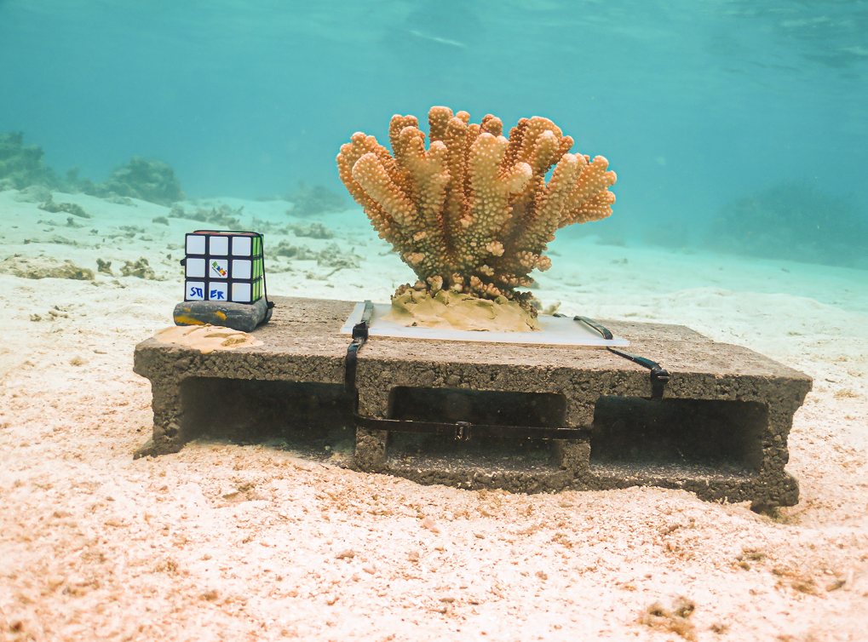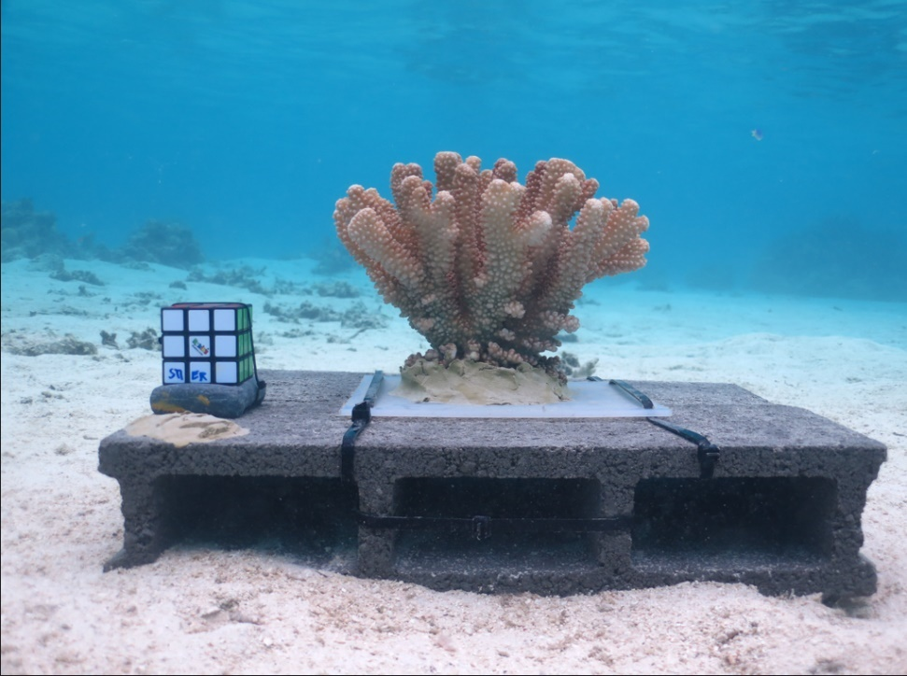Finally, before importation for alignment, delete any photos that are still out of focus, where the focal object is heavily obscured, or the image quality is otherwise low and beyond fixing via further adjustments.

**2. 3D Model Creation**

Although other software is available for the alignment and processing of still images into 3D photogrammetric objects, here we cover steps for doing so using Agisoft Metashape Pro (hereafter, Metashape). Metashape is computationally rigorous, and will work most quickly on machines that feature upgraded processing speeds (GB of RAM) and higher-end graphics cards. However, Metashape does run, albeit slowly, even with off-the-shelf laptop or desktop specifications. Download available [here](https://www.agisoft.com/downloads/installer/); Specs listed [here](https://www.agisoft.com/downloads/system-requirements/)

**Alignment**

The objective of this step is to align each image (referred to in Metashape as a “camera”) relative to each other using commonly identified locations in each image (“tie points” or “key points”). The 3D object created from photo alignment is called a “sparse point cloud”. Alignment of each focal object (with ~100-150 images) should take between 20 minutes and 1 hour to complete, depending on processing specifications.

*Single focal object*

* **Add Photos** under the **Workflow**menu, which will be gathered into a “Chunk”. Photo tiles can be viewed by selecting “**View**” and “**Photos**”.
* 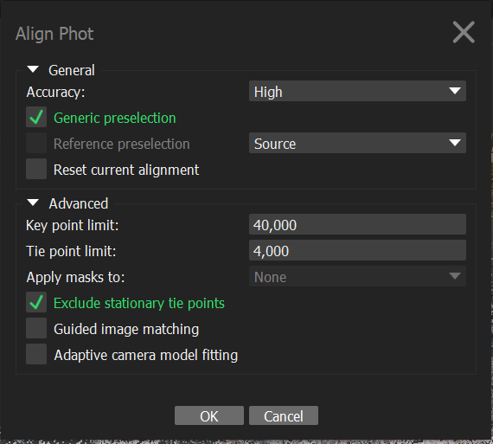Select **Align Photos** (the following default settings are usually sufficient)
* Check that all photos aligned. Under “**View**”, make sure the **Workspace** panel is visible. In the **Workspace** panel, expand “Chunk 1”, where the number of total and aligned cameras will be listed.
* Remove photos that did not align (usually <5%). Aligned photos will feature a grey checkmark in the top-right corner in the respective photo tile. Alternatively, repeating the photo alignment without selecting “reset current alignment” will sometimes successfully align photos that did not pass the initial alignment.

*Align batches of photos*

Matthew Gottlieb, a UCSB alumni, helped the Ocean Recoveries Lab develop Python scripts that would facilitate batch processing of multiple focal objects. These files are available [here](https://github.com/Mgla96/OceanRecoveryLabScripts).

To align multiple folders of photos at a time:

* Select “**Tools -> Run Script**” (or **Cmd/Ctrl +R**) and link to the downloaded script file “**align_and_delete.py**”
* Follow the prompts, which will help select the appropriate operating system (PC or Mac), then guide the user to select the input folder (parent folder containing sub-folders of photos, one folder per focal object) and the output folder (destination folder for Metashape files)
* One Metashape project will be created for each folder, with the same name, each containing an aligned set of photographs after processing is complete. The script will also automatically delete any pixels with a reprojection error of 0.5px from the sparse cloud created by photo alignment.
* Default settings are the same as provided above, but can be adjusted at the head of the python file in a text editor

*Alignment notes*

* Right clicking on a photo tile and selecting “**View Matches**” will show you how each image aligned relative to others. In case of poor alignment, this may help to indicate problems within a photo-set (minimal overlap, changing lighting between photos, etc) that led to poor alignment.
* Similarly, navigating to “**Model -> Show/Hide items** -> **Show Cameras**” will indicate where different images were taken relative to the object, and may help identify gaps in photo coverage during image capture.
* 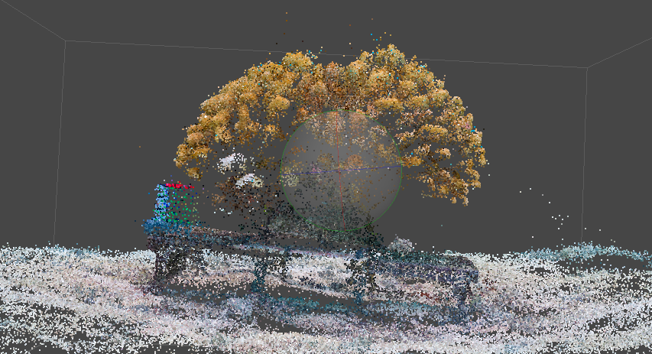Photos are stored by default as references based on relative file paths. If either the Metashape project file (.psx) or photo files are moved after initial creation, they will have to be re-linked. This can be done by right clicking on a photo tile, choosing **Change paths** (apply to all cameras) and finding the desired photo location. Adjusting one path with all cameras selected will adjust all photo paths.

Sparse point cloud after image alignment including focal object (coral), 3D scale bar (Rubik’s cube), and background (sand and cinderblock)

**Scale Bar Calibration**

The objective of this step is to calibrate scale bars from the photographed object of known volume (in this case, Rubik’s Cube). Scale bar calibration takes 5-10 minutes per focal object.

* On either the sparse point cloud of the Rubik’s cube or on a selected photo, right click a corner of Rubik’s cube and select **Add Marker.** Add 4 total markers for creation of at least three scale bars, ideally positioned along three orthogonal axes (X,Y,Z)**.** A list of markers is available in the **Workspace** panel. Selecting each marker will indicate how many “projections” of that marker were created, or the number of images where the selected point is visible, at the bottom of the **Workspace** panel.
* In a minimum of three photos, click and drag each marker to the intended respective corner of the Rubik’s cube. Blue flags above photo tiles will indicate that marker positions were auto-generated, green flags will indicate that at least one marker has been manually adjusted. Adjusting markers should take less movement for each attempt in a new photo. For best results, view the cube in photos that captured different angles to best aid the 3D orientation of marker placement. If a marker consistently is poorly adjusted to a particular corner, try again or select a new corner.
* Create scale bars by navigating to the **Reference** pane (**View -> Reference**) and selecting two markers. Then, right click and select **Create Scale Bar*.*** These will appear in the **Scale Bars** panel at the bottom of the **Reference** pane**.** Create 3 scale bars.
* Double click under “**Distance**” in the **Scale Bar** panel and enter the length of each scale bar. For a standard Rubik’s cube, this is 5.7cm or 0.057 m. **Accuracy** will automatically be entered as 0.001 m.
* Click **Update** (refresh symbol)at the top of the **Reference** pane.

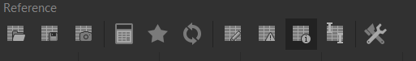

* 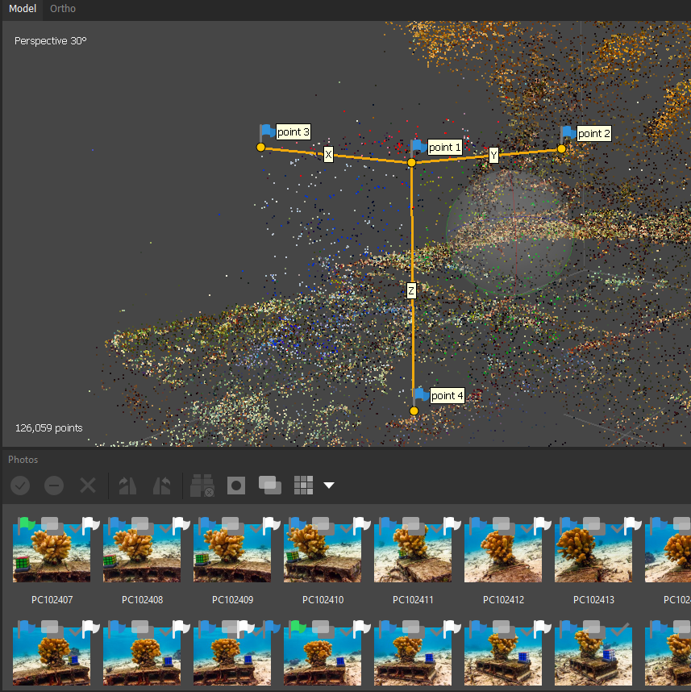Click on**Estimated Distances** (Chart with info symbol in bottom right corner) at the top of the **Reference** pane. The difference between the estimated distance value for each scale bar object and the provided distance (actual length) is listed under “**Error**”. From our experience, a reasonable goal for minimal scale bar error using the Rubik’s cube is 0.005 m, or 5mm.

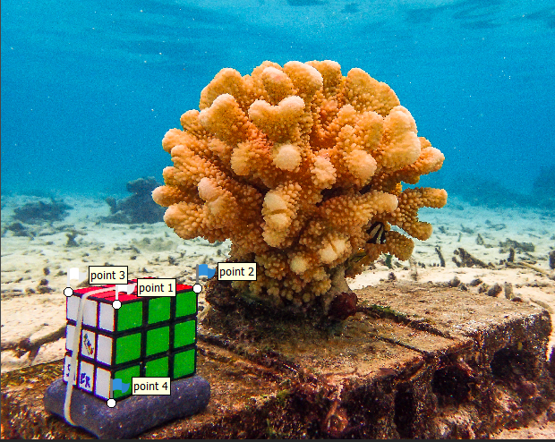

Scale bars on sparse point cloud Adjusted markers on Rubik’s cube

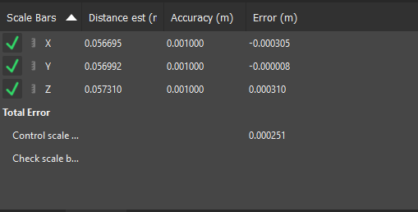

Scale bar window in Reference Panel (Estimated Distances) after calibration

*Scale Bar Calibration notes*

* If the scale bar error is too high for your analytic goals, try manually refining the marker locations and selecting **Update** after each movement.
* Often, one of four markers will align more poorly than the others, and adjusting this one marker will reduce error across all three scale bars. Occasionally, it may be necessary to create a new marker and scale bar, possibly using different Rubik’s cube corners. The biggest contributor to difficulty aligning scale bars was incomplete photo coverage of the Rubik’s cube.
* From a brief test, creating a third scale bar greatly improved measurement precision (>5%), but creating additional scale bars beyond 3 provided dramatically diminishing returns (<1%).
* Scale bar calibration can also be performed after the completed 3D model is generated, when it is easier to place initial markers on the corners of the 3D model of the Rubik’s cube than on the sparse cloud and fewer adjustments of marker position are usually necessary. In that case, alignment will not be optimized. Based on some preliminary testing, performing the scale bar calibration before and after model creation led to <1% difference in volumetric measurements.

**Optimization**

The purpose of this step is to optimize alignment using positional information provided by the user-created scale bars. Optimization takes <1 minute per focal object.

* Remove pixels from the sparse cloud that were not assigned a position with high precision. Navigate to **Model -> Gradual Selection**. Select **Reprojection Error** and set the desired criteria (Ocean Recoveries Lab uses a threshold of 0.5). Once poorly projected pixels are selected, hit the **Delete** key or navigate to **Edit -> Delete Selection**
* Optimize camera alignment. Select the star in the **Reference** panel with the pictured, default settings selected

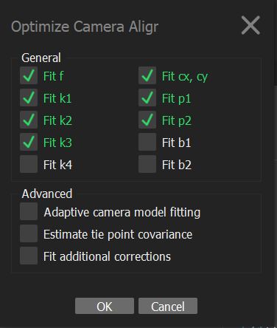

*Optimization Notes*

* Pixels with reprojection error >0.5 will be automatically deleted using the Alignanddelete.py python code for batch alignment. Optimization will also be automatically performed
* If scale bars are created after 3D model creation instead of after alignment (see scale bar calibration notes), optimization will not change camera alignment

**Building 3D object**

The objective of these steps is to create a complete 3D model from a set of aligned images of a focal object. Collectively, these steps will take 1-5 hours per focal object, depending on hardware configuration.

* Remove points outside of area intended for final 3D model. This will substantially improve processing speed by limiting the amount of the sparse point cloud being modeled
  + *Manual*: Use selection tool (dashed rectangle) from the top toolbar to select all sparse point cloud points that include the focal object. Selection shape can be changed to “circle” or “free-form” if desired. Once all focal points are selected, navigate to **Edit -> Crop Selection**. Use the selection tool in empty space or choose **Reset Selection** from the options on the **Selection** toolbar iconto deselect sparse cloud points.
  + *Automatic*:Adjust the region (grey bounding box) to be as small as possible while still enclosing all of the focal object and scale bar in the sparse point cloud created by image calibration. Bounding box parameters are adjusted with the **Move Region** and **Resize Region** tools in the top menu. Once the bounding box is in the desired position, use the python code (**Cmd/Ctrl + R)** titled “boundingBoxScript.py”. This will remove all sparse cloud points outside of the region.
  + *Note*: if scale bars are already completed and calibrated, the scale bar does not have to be included in the 3D model. If using *Manual* selection, choose “No” when prompted whether to delete markers when cropping selection. The *Automatic* (python-based) region selection tool will not delete markers or scale bars.
  + *General navigation shortcuts*: Selections and region adjustments often require changing the view of the sparse cloud or model. A few keyboard shortcuts while in **Navigation** mode (mouse icon on toolbar is selected) are:

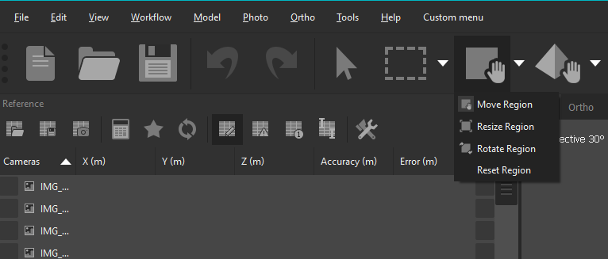

* + 1. Shift + click + mouse drag: Zoom in and out
    2. Cmd/Ctrl or Alt + left click + mouse drag: Move fixed reference frame
    3. Right click + mouse drag: Move fixed reference frame
    4. Left click + Mouse drag: Rotate reference frame

Useful icons on main toolbar, including navigation (mouse icon), selection (dashed rectangle), and region adjustment (solid square with hand)

* *Note:* It can be difficult to discern from the sparse cloud which points are included in the focal object. Use color as a reference, or generally give a buffer zone when isolating the focal object so all relevant points are passed on for model creation.
* 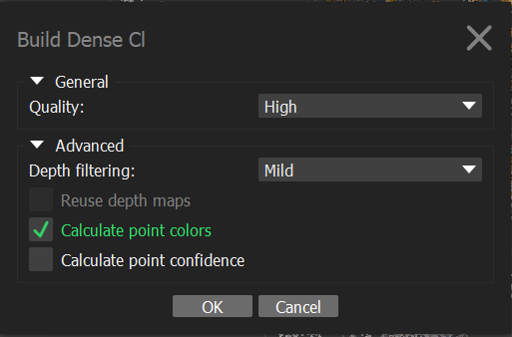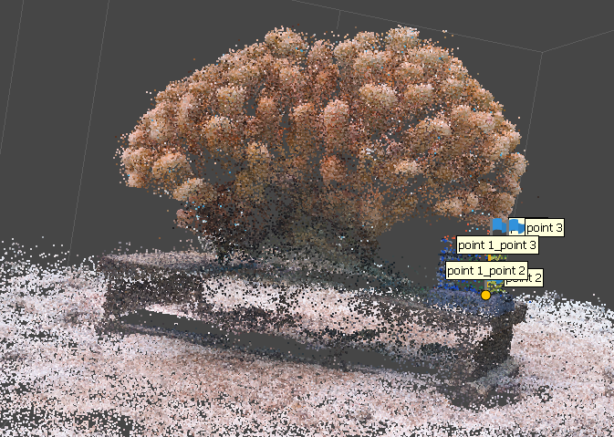Navigate to **Workflow -> Build Dense Cloud**. This adds points between those in the sparse cloud and calculates depth maps. This step takes 20 min – 2 hours, depending on processing speed. The default settings are generally appropriate:

Settings and result of Dense Cloud (and Depth Map) creation

* 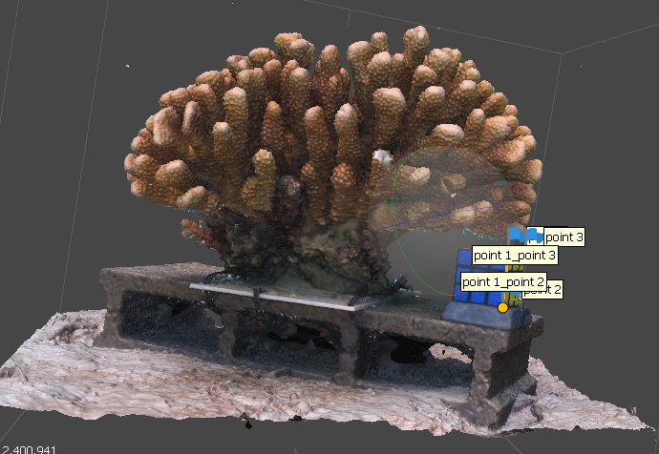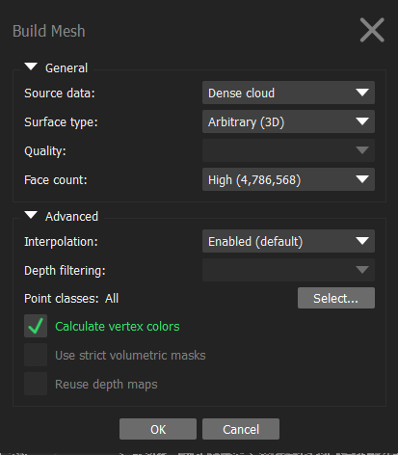Navigate to **Workflow -> Build Mesh**. This creates a polygonal mesh model based off of the dense point cloud data. Building the mesh will take 20 min – 2 hours, depending on processing speed. The default settings (below) are generally appropriate:

Settings and result of 3D mesh creation

* 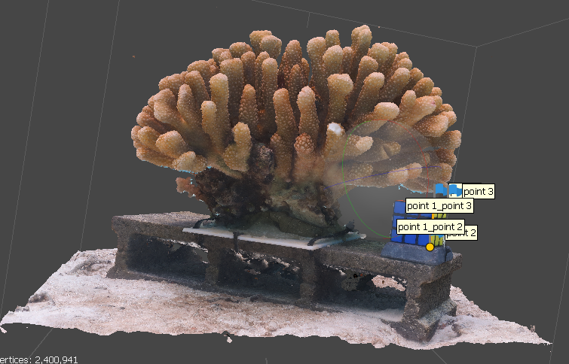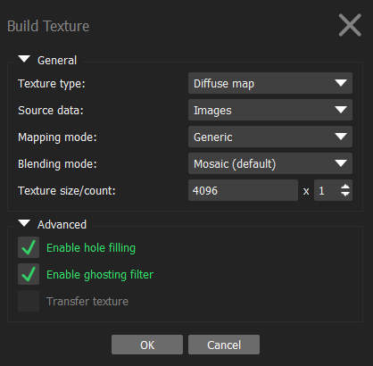Navigate to **Workflow** **-> Build Texture**. This will overlay texture from images onto the 3D mesh. Measurements can be made without the texture, but the texture makes subsequent cropping and quality analysis easier. Texture creation takes 10min – 1 hour. The following are the settings for texture building:

Settings and result of texture creation

*3D Model Creation Notes*

* Using the Ocean Recoveries Lab python code, 3D models can be created in a batch using a collection of Metashape projects where photos have been aligned. This code automatically removes points outside of the bounding box, then builds dense cloud, mesh, and texture for each project. To use this code, navigate to **Tools -> Run Script (Cmd/Ctrl + R)** and select **“opt_and_build.py”**. Settings can be adjusted by opening the script in a text editor. For proper operation of this tool, make sure that:
  + The bounding box is set so that no part of the focal object sparse cloud will be cropped out
  + Photos are properly linked to their tiles in the Metashape project (i.e., there hasn’t been any change in the relative file path from source photos to aligned project file)
  + GPU devices are NOT selected (see following note)
  + If the code successfully cycles from one project to another, it should continue to work unless it crashes. Watch for one successful overturn, then processing can be left. Projects will be saved and crash reports generated if the code does not complete 3D model creation for all projects.
* Selecting a GPU device to perform 3D model creation can substantially speed up processing. This is done by navigating to **Tools -> Preferences**, then opening the **GPU** tab and checking the box for your machine’s GPU. However, unless your GPU is extremely powerful, this usually leads to frequent crashes using the batch processing python code (we experienced this using both a consumer PC Laptop and a high power Mac Desktop). However, enabling GPU processing can be an effective tool to speed up computing time for one project at a time.

**Model Cropping**

This step isolates the focal object from the background and 3D scale bar for subsequent measurements and takes 5-20 minutes per focal object.

* Using the **Selection** tool (dashed rectangle on primary tool bar), isolate areas of the 3D model that should not be included for analysis. In our coral example, this includes the cinder block, mounting epoxy, areas of dead coral, and attached substrate near the base. Use of the **Free-form Selection** tool is highly recommended, as it is much more flexible than the shape-based tools.
* *Free-form selection tool tips*
  + The selection tool selects areas of the object on all sides in the path of the selection, not just the “screen-facing” side. Therefore, angling the view so that only the area targeted for selection is highlighted is extremely important so areas of the focal object aren’t accidentally deleted. Especially while learning the tool, make a selection and rotate the object to make sure that no unintended areas are highlighted.
  + While in the selection tool, right click + mouse drag will move the view in a fixed reference frame. See *General navigation shortcuts* in the 3D Model building section of this manual for other tips in **Navigation** mode which will be essential for efficient cropping
  + Holding down **Cmd/Ctrl** between subsequent tracings with the selection tool will highlight more than one selection
* Once a selection has been made, use the **Delete** key or navigate to **Edit -> Delete Selection**. Clearing the selection and selecting **Edit -> Undo (Ctrl + Z)** will restore the deleted section without highlights, which can be an effective way to ensure that the focal model remains unaffected by a deletion. Select ”No” if asked whether to delete markers outside of the focal area.

*Model Cropping Notes*

* Once cropped and saved, a section of the model cannot be restored without re-doing the 3D model creation step, so we recommend saving the cropped model as a separate file or exporting the initial model (**File -> Export Model**) for retrieval if it becomes necessary.
* 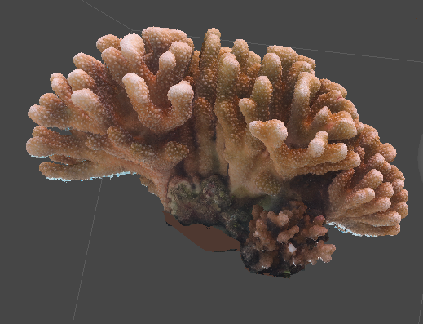An alternate approach to cropping is to use masks on the photos before alignment. This can be done using a combination of the **Magic Wand, Magic Scissors,** and **Magic Paint** tools to outline an area, then performing **Right Click + Add Selection**to create a mask around the focal object and scale bar (scale bar must be included for later calibration). Then, during *Alignment*, select “Apply Masks to: Tie Points” in the settings. For our purposes, even 30 seconds of processing per photo rapidly became unwieldy and cropping was a more efficient approach. However, for projects using less complex focal objects, more distinct and uniform backgrounds, and fewer images per focal object, masking may dramatically reduce both computing time during alignment and 3D model creation and eliminate the need for manual cropping, which is the most user-error prone step of the entire operation.

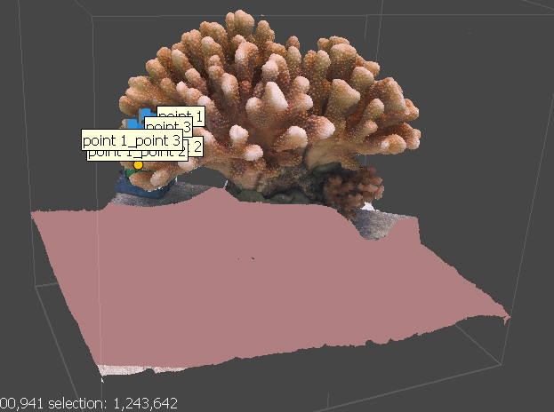 Model during selection and cropping Model after cropping (with closed holes)

**Metashape Measurements**

Once cropped, the object is ready to be measured in a number of ways in Metashape. These can be done in any order, except:

* Surface area must be measured first for corals. This is because holes in the mesh must be closed for further measurements, but that would increase surface area artificially, because the area on the bottom of the coral where it contacts the substrate is not an accessible part of the colony. For other focal objects, this may not be an issue and surface area can be measured in any order. To measure surface area, navigate to: **Tools -> Mesh -> Measure Area and Volume**. Area will be provided in m2

After surface area has been measured, close holes in the mesh to create a watertight object for volumetric analyses. Navigate to **Tools -> Mesh -> Close Holes** and increase level to 100%. Now, volume and linear dimensions can be measured in any order.

* Volume: navigate to **Tools -> Mesh -> Measure Area and Volume**. Volume will be provided in m3
* Linear dimensions. Measure by creating markers on the 3D object (**Right Click** on the desired location and select **Add Marker**) and creating a scalebar (follow instructions from *Scale Bar Calibration*). The length of the scale bar in m will be provided in the **Estimated Distances** tab of the **Scale Bar** window on the **Reference** panel. The **Ruler** tool can also be used to make measurements, but this is less reproducible unless coordinates are collected as data. *Note*: Do **NOT** enter any manual distances or select **Update** after creating scale bars for measurements, as this would change the scaling of the entire object in a way that is not reversible once the 3D scale bar model has been cropped out.
  + Length: Place two markers at opposite ends of the longer horizontally-oriented dimension of the focal object. As much as possible, try to make sure that the markers are at an even height or the angle of the scale bar will affect the measurement.
  + Width: Place two markers at opposite ends of the shorter horizontally-oriented dimension of the focal object. As much as possible, try to make sure that the markers are at an even height or the angle of the scale bar will affect the measurement.
  + Height: Place one marker directly in the center of the base of the coral. To do this, flip the model upside down and **Right Click** in the center of the base and select **Select Drawing Plane**. This will set a plane perpendicular to the vector of the selected point. If the drawing plane does not extend in a roughly horizontal plane that is parallel to the orientation of the base, **Right Click** and select **Reset Drawing Plane** and try again in a different location. Once the drawing plane is set, place a marker in the center of the base, then **Right Click** and select **Reset Drawing Plane**. Finally, add a marker at the highest point of the focal object and create a scale bar. If the vertical and horizontal measurements are not roughly 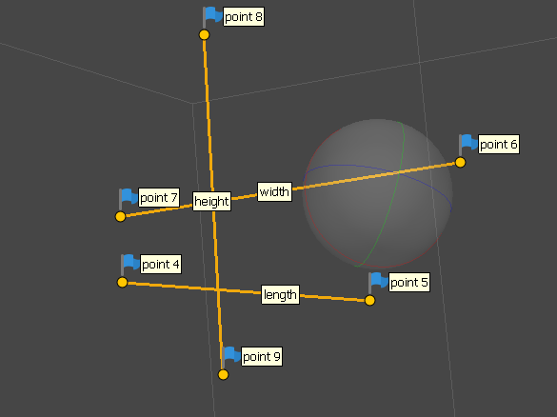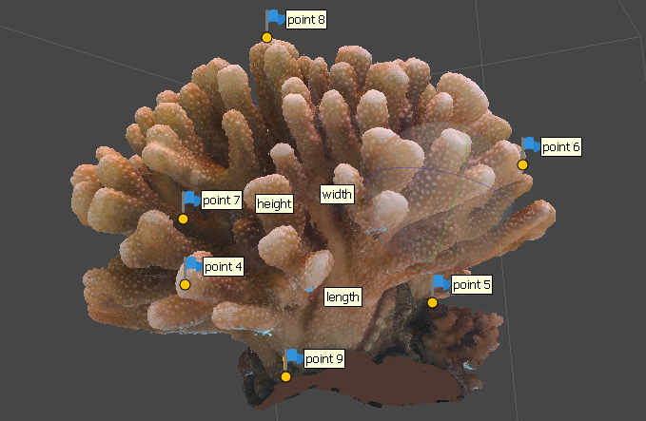orthogonal, reset and try again.

Coral with linear measurement markers Scale bars for linear measurements

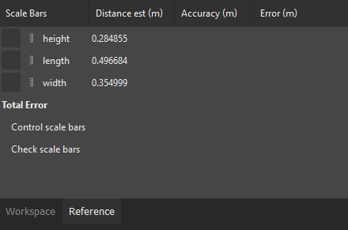

Measurements from scale bars in **Estimated Distance** window of **Reference** tab

**Subsequent Measurements**

For many other common 3D measurements, including those of interest in corals, you must first calculate the Convex Hull volume, or the smallest polyhedron which can enclose an entire 3D object. The Ocean Recoveries Lab still has not identified an easy way to do this using Metashape, so we used Meshlab (available [here](https://www.meshlab.net/#download) for free).

* Export objects from Metashape (**File -> Export -> Export Model**) as .obj files. Use the following settings:

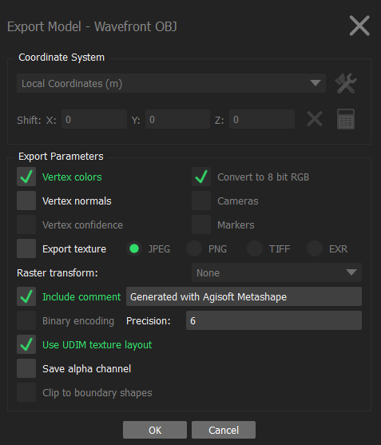

* In Meshlab, navigate to **File -> Import Mesh** (**Cmd/Ctrl + I**)
* Remove any vectors that are not attached to the focal object. These are usually miniscule and unobservable, but must be removed before convex hull calculations. Navigate to **Filters -> Cleaning and Repairing -> Remove Isolated Pieces** (either selection criteria, “wrt Diameter” or “wrt Face num.” is fine, use the default settings)
* Draw the convex hull. Navigate to **Filters -> Remeshing, Simplification, and Reconstruction -> Convex Hull**
* With the Convex Hull highlighted in the Layers window, navigate to **Filters -> Quality Measure and Computations -> Compute Geometric Measures**. Measurements will appear in the console in the bottom right corner, scroll up to find surface area and volume.

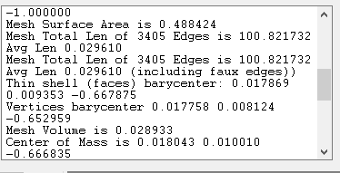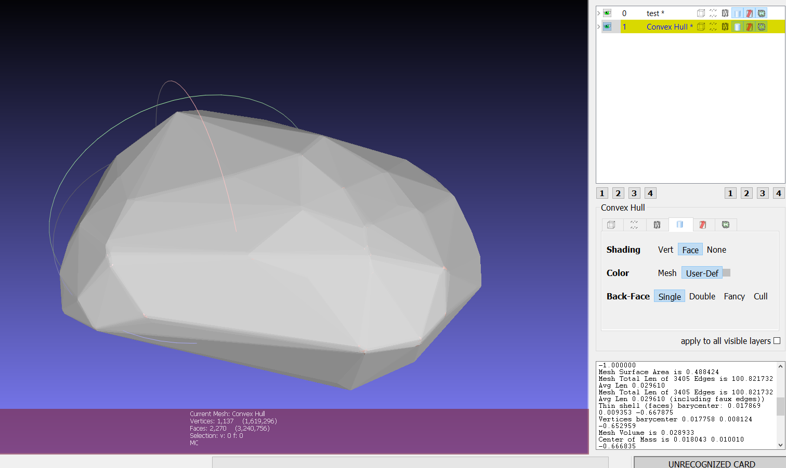

Convex hull in Meshlab and resulting geometric measurements. Surface area and volume are highlighted for emphasis



* Additional 3D calculations for focal objects (with an emphasis on corals) include:
  + Interstitial Space (Convex Hull Volume – Focal Object Volume) – amount of empty space between focal object and convex hull
  + Convexity (Focal Object Volume/Convex Hull Volume) – proportion of convex hull occupied by focal object (complexity proxy)
  + Sphericity (π^1/3 * 6 * (Focal Object Volume ^ 2/3))/Focal Object Surface Area) – Estimates how closely 3D object approximates a sphere or evenness of linear dimensions
  + Surface Area/Volume ratio (Focal Object Surface Area / Focal Object Volume)
  + Packing (Focal Object Surface Area / Convex Hull Surface Area) – proxy for rugosity/surface complexity

*Convex Hull Note***s**

We encountered a small number of instances where Metashape .obj files were not imported neatly into Meshlab and convex hull calculations were not possible. We do not have an explanation for this problem or a solution, but it was limited to only a small number of files (<5%).